**Batch 2: Group 1**

**Assignment 6**

**Aim:** Get your product backlog ready: Estimate the size of your backlog items and do everything you think you need to do to be ready for sprint planning.

**Objectives:**

1. Define and prioritize user stories for the development of a To-do list application.
2. Estimate the size and effort required for each backlog item to facilitate sprint planning.
3. Identify dependencies, technical requirements, and acceptance criteria for backlog items to ensure clarity and readiness for development.

**Theory:**

**User Stories:**

User stories represent desired features or functionalities from the perspective of end-users. These stories typically follow a simple template: "As a [user], I want to [action], so that [benefit]." For a To-do list application, examples of user stories might include "As a user, I want to add new tasks to my list" or "As a user, I want to mark tasks as completed."

**Estimation Techniques:**

Estimating the size or effort of backlog items helps teams prioritize work and plan their sprints effectively. Common estimation techniques include story points, which represent the relative complexity or effort of a task compared to other tasks. Teams can use techniques like Planning Poker to assign story points collaboratively based on discussions around complexity, risk, and uncertainty.

**Acceptance Criteria:**

Acceptance criteria define the conditions that must be met for a user story to be considered complete. These criteria ensure that the development team and stakeholders have a shared understanding of what constitutes a successful implementation. For a To-do list application, acceptance criteria might include functionality like task creation, editing, deletion, and sorting.

**Implementation:**

1. Add all user stories.

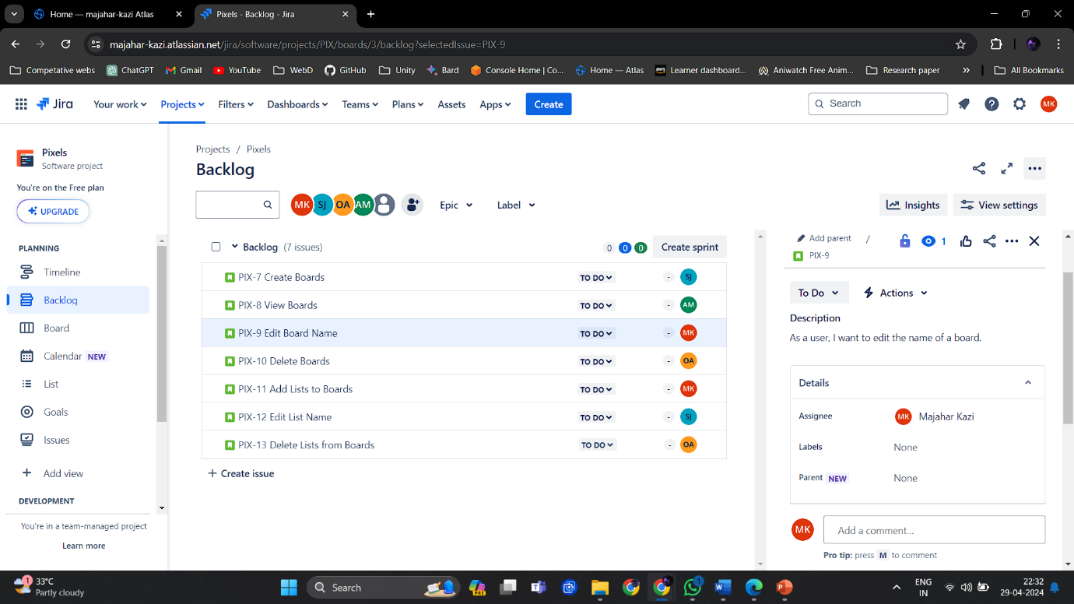

1. Add all tasks.

1. Create sprints and prioritize the tasks according to their value in each sprint.

1. Sprint 1 and Sprint 2

1. Sprint 3

1. Sprint 4

1. Sprint 5 and Sprint 6

1. Edit Sprint start and end dates according to schedule.

1. Link issues or create child issues.

1. Create and manage epics.

1. Start Sprint.

1. Board:

1. Timeline:

10. Calendar:

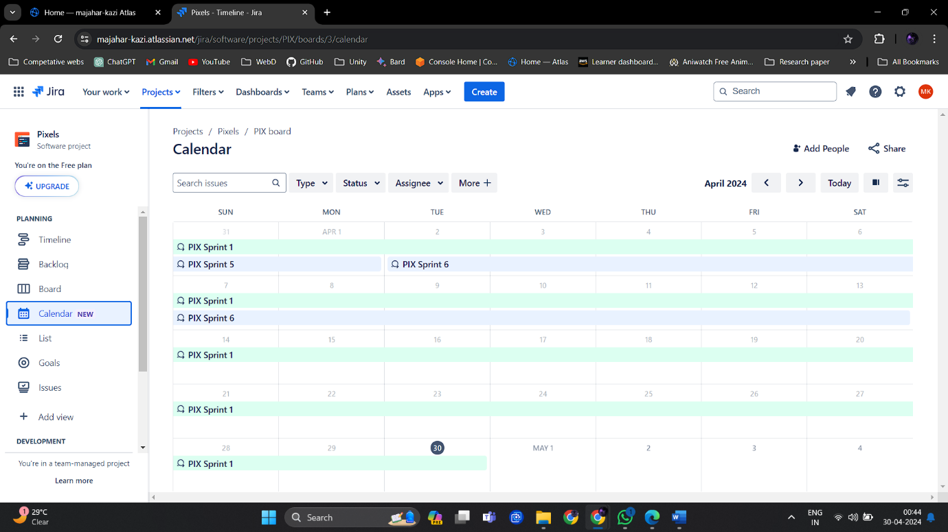

11.List:

**Conclusion:**

By refining and estimating backlog items, we've prepared our product backlog for sprint planning. We've clarified user needs through well-defined user stories and established criteria for successful implementation. With estimates in place, the team can prioritize tasks effectively and plan sprints that align with project goals and stakeholder expectations. This readiness ensures a smooth transition into the execution phase of our To-do list application development.